**FastTracker Rebuild Design/Development Considerations**

**Web Site Theme Colors**

Colors in the logo:

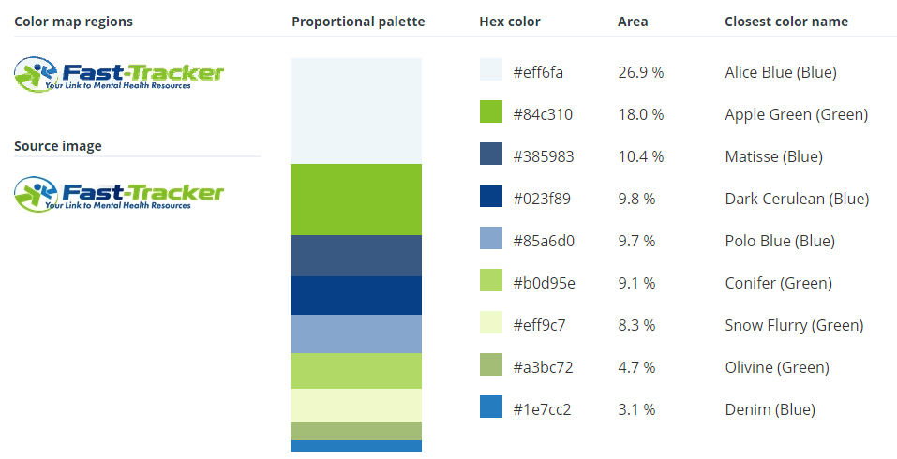

Colors in existing site:

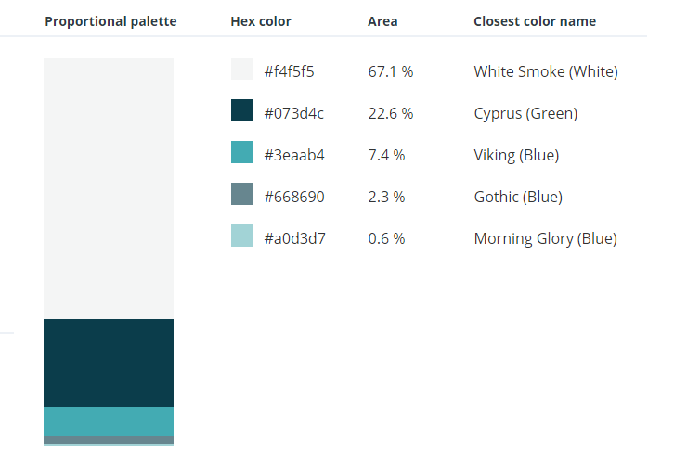

Should we stick with the existing colors or incororate some colrs from the logo pallete? The norm is to incorporate colrs from the logo into the site theme.

**Search Functionality**

Should we retain the existing search functionality, using the separate text boxes for key words, services, insurance plans and Zip Code? The alternative is to use a single search text box that searches all content and can return results from clinic profile, resource pages and any other site content. Many sites use this type of search.

Also related to search – Should the search results all be returned in “Most Recentky Updated” descending order?

**News Editor**

Should we retain the existing functionality for the news that utilizes the external WordPress site? I’m certain that it impacts performance. The alternative is to use a built-in rich text editir and diplay the content directly to the page without going external. The Google Calendar seems to word fine for events so I don’t see any reason to change at this point.

**Clinic Availability**

Do you want to retain the current way we track availability using the preset values (Available within 2–4 weeks, etc.) or utilize the check box method the the SUD site currenlty uses? Whichever way you decide will have no impact on development time.

Additional Question:

Since we are separating the services from the clinic level and connecting them to the location level do we also want to do that with the providers? I’m not sure if providers only work at certain clinics…